Mail Entry Form and make Checks payable to:

CASA of the Eleventh Judicial Circuit
Superhero 5k, Family Fun Walk/Run
PO Box 1142,
Lewisburg, WV24901
NAME: ____________________________ DOB: ____AGE: _____ SEX: ____

PHONE: ____________ Email Address __________________________

ADDRESS: ___________________ CITY: ______________ STATE: ____ ZIP_______

Check one 5 K: _____ ($25.00 before May 20th $30.00 after)
Family Fun Walk/Run: ______ (sponsor form attached)

Adult Shirt Size: Small ____ Medium ___ Large ____ X Large _____XX Large____

Youth Shirt size: Large ______ Medium_____

WAIVER:
I know that running a road race is a potentially hazardous activity. I should not enter unless I am medically able and properly trained. I assume all risks associated with running this event. I understand that events maybe held over public roads and facilities open to the public during this event and upon which hazards are to be expected. PARTICIPATION CARRIES WITH IT CERTAIN INHERENT RISKS THAT CANNOT BE ELIMINATED COMPLETELY RANGING FROM MINOR INJURIES TO CATASTROPHIC INJURIES INCLUDING DEATH. I UNDERSTAND AND AGREE THAT IN CONSIDERATION OF BEING PERMITTED TO PARTICIPATE IN THE EVENT, I AND ANY REGISTERED PARTY, THE HEIRS, PERSONAL REPRESENTATIVES OR ASSIGNS OF YOU OR THE REGISTERED PARTY Having read this waiver and knowing these facts and in consideration of your accepting my entry fee, I, for myself, and anyone entitled to act on my behalf, waive and release the City of White Sulphur Springs and CASA of the Eleventh Judicial Circuit, and all sponsors, their representatives and successors, for all claims or liabilities of any kind arising out of my participation in this event. BY INDICATING YOUR ACCEPTANCE OF THIS AGREEEMENT AND WAIVER, YOU ARE AFFIRMING THAT YOU HAVE READ AND UNDERSTAND THIS AGREEMENT AND WAIVER AND FULLY UNDERSTAND ITS TERMS. YOU UNDERSTAND THAT YOU ARE GIVING UP SUBSTANTIAL RIGHTS, INCLUDING THE RIGHT TO SUE. I UNDERSTAND THAT ANY PHOTOS TAKEN DURING THIS EVENT CAN AND WILL BE USED IN FUTURE PUBLICATIONS AND ADVERTISING OF THIS EVENT. I ACKNOWLEDGE THAT I AM SIGNING THE AGREEMENT AND WAIVER FREELY AND VOLUNTARILY AND INTEND BY MY ACCEPTANCE TO BE A COMPLETE AND UNCONDITIONAL RELEASE OF ALL LIABILITY TO THE GREATEST EXTENT ALLOWED BY LAW.

____________________________________________________________

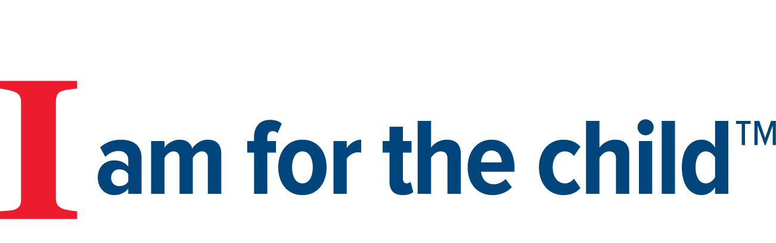
Signature (Parent’s Signature If under 18) Date

